

**Shenzhen Yuhesen Technology Co., Ltd.**

**MK Robot-02 Four Wheel Differential Steering Drive-by-wire Chassis**

**User manual V2.2.0**

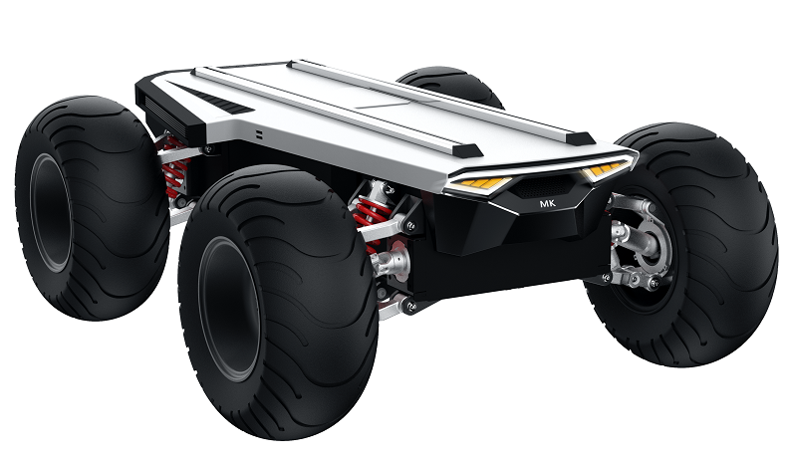

**CONTENTS**

1. Foreword 1

2. Safety information 2

3. Introduction 4

3.1. Product list 4

3.2. Performance parameters 5

4. Product presentation 6

4.1. State indicator 8

4.2. Instructions of electrical interface 9

4.3. Instructions of remote controller 10

4.3.1. Remote controller description 17

4.3.2. Remote controller buzzer warning instructions 28

4.3.3. Control command and motion description 28

5. Getting started 15

5.1. Use and operation 15

5.2. Charge 15

5.3. Development 17

5.3.1. Can interface protocol 10

5.3.2. Connection of can cable 10

5.3.3. Instructions for VCU Common Protocols 10

6. Attention 36

6.1. Attentions for battery 36

6.2. Attentions for charging 36

6.3. Attentions for usage environment 37

6.4. Attentions for remote operation 37

6.5. Attentions for external electrical extension 37

6.6. Other attentions 38

7. Common Q&A 39

8. Specifications 40

# 1. Foreword

(1) Thank you for purchasing our product, this user manual is applicable to MK Robot-02 four wheel differential steering Drive-by-wire Chassis (hereby referred to as "MK Robot-02 ").

(2) Before use, please carefully read this user manual and attentions, and correctly use strictly in accordance with this manual.

(3) For the loses caused by serious violation of this user manual, we undertake no responsibilities.

(4) Please well keep this manual for user reference during your operation.

(5) Professionals are required for commissioning, connection and installation of the chassis equipment to avoid irretrievable loses.

(6) DO NOT install, remove or replace equipment lines with electricity. If it is necessary to commission this product with electricity, please select the special commissioning tools with good insulation.

(7) Please use this product under the conditions allowed by laws and regulations, so that the public property or life safety will not be affected.

(8) We will irregularly update this product, the contents of update will be added into the new manual without notification.

(9) This manual may contain the contents which are not correct in technology or which do not comply with the operation. In case of problems which cannot be solved during use of this manual, please contact with the customer service or technical department of us.

(10) As for the contents of this manual, we will try our best to ensure that they are correct and accurate. In case of any improper or incorrect contents, please contact us for confirmation, thank you!

# Safety Information

The information herein does not include how to design, install or operate a complete robot, nor the peripheral equipment which may affect the safety of this complete system. The design and use of the complete system comply with the safety requirements formulated in the national standards and specifications. The integrators and end customers of MK Robot-02 are responsible for being sure to comply with practical laws and regulations of relevant countries to ensure that the application of the complete robot will not cause any major danger. These include but are not limited to the following:

* **Effectiveness and responsibilities:**
* A risk evaluation shall be conducted to the complete robot system. All the additional safety equipment of other machineries defined by risk evaluation shall be connected. It shall be ensured that, the design and installation of the peripheral equipment of the whole robot system, including software and hardware system, are correct.
* This robot is not equipped with relevant safety functions that a complete autonomously moveable robot shall have, including but not limited to automatic collision avoidance, fall prevention and alarm for creature approaching, etc. For relevant functions, the integrators and end customers are required to conduct safety evaluation in accordance with relevant regulations and feasible laws and regulations to ensure that the developed robot has no any major danger or potential safety hazard during actual application.
* Collecting all the documents of technical files: Including risk evaluation and this manual. Before operation and use of equipment, the existing safety risks may be known.
* **Environments:**
* For first use, please carefully read this manual to understand the basic contents and operation specifications.
* For remote operation, please select the areas which are relevantly open. This chassis is not equipped with any sensor for automatic obstacle avoidance.
* This chassis shall be used under the temperature of -20°C~50°C.
* The chassis is not customized for IP protection grade, the IP protection grade of this chassis is IP42.
* **Inspection:**
* Inspecting to ensure that the batteries of the equipment are full. Ensuring that the chassis has no abnormality. Inspecting whether the battery of the remote controller is full.
* **Operation:**
* Ensuring that operation is conducted in a relatively open place. And remote control shall be conducted with sight distance.
* MK Robot-02 The maximum load is 50KG, The maximum speed is 1.5m/s.

To ensure the normal operation of the vehicle, the maximum payload sahll not exceed the corresponding load value during use.

* Please charge the device in time when the low battery alarm occurs (when the battery is lower than 10%, the whole vehicle will alarm as a level 1 fault, and flash the alarm indicator to give the corresponding low battery prompt).
* In case of equipment abnormality, please stop use immediately to avoid secondary damage.
* In case of equipment abnormality, please contact relevant technicians, DO NOT process without permission.
* Please use the equipment in the environment which meets the IP protection grade requirements of the equipment.
* DO NOT directly push the chassis.
* During charging, please ensure that the environment temperature is higher than 0°C.
* **Maintenance:**
* In case of serious tire wearing, please replace timely.
* If the battery will not be used for a long time, when the battery is fully charged, please charge the battery regularly in each month.
* The battery shall be used once a month at least.

# 3. Introduction

MK Robot-02 is a versatile drive-by-wire robotics mobile platform, it adopts differential steering and four independent motor drive form. Due to it’s compact design and 0m turning radius, the chassis reach a high flexibility in various indoor and outdoor applications. Matching with front and rear double wishbone independent suspension, the chassis has strong stability and excellent shock absorption and the chassis can pass through the common obstacles, such as speed bump, etc. Therefore, it is more applicable for long-term outdoor traveling; And this chassis is a underlayer control system structure based on VCU vehicles control, it uses CAN bus management, having the features of high precision and modularization, etc. By equipping with the modules of navigation systems, GPS and IMU, cameras etc., this chassis is widely used in unmanned patrol, logistics, transportation, scientific research and various new applications and explorations requiring for mobile chassis.

## 3.1. Product list

After delivery, please carefully confirm the product list:

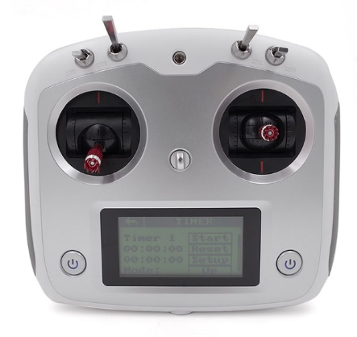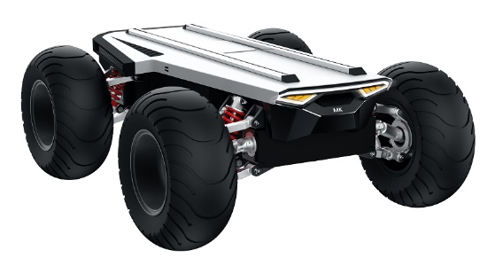

Charger (48V) *1

Chassis *1

Product manual *1

Remote controller *1

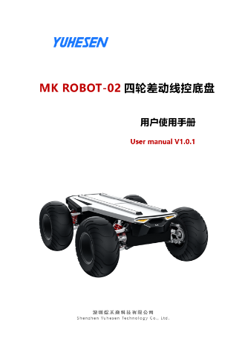

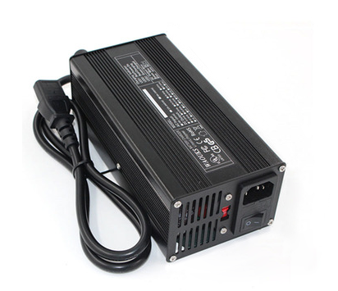

## 3.2. Performance parameters

Table 2 - 1 MK Robot-02 Performance Parameter Table

|  |  |  |
| --- | --- | --- |
| **Parameter type** | **Performance** | **Parameter** |
| Structural size and weight | Dimensions(W*D*L) | 920*740*350mm |
| Weight | 70kg |
| Drive | Differential steering, motor drive |
| Suspension | Front and rear double wishbone independent suspension |
| Material | Q235+Aviation aluminium alloy |
| Ground clearance | 150mm |
| Wheelbase | 600mm |
| Wheel track | 600mm |
| Tire type/diameter | 13*6.50-6，324mm |
| Basic configuration | Driving motor | 4*400W, servo motor |
| Reduction Ratio | 35 Speed ratio |
| Battery type | 48V/18AH lithium battery/BMS system |
| Charging time | ≤4h |
| Charging method | 48V/5A, manual charging by charger |
| External power supply | 48V/10A-24V/15A-12V/15A |
| Braking mode | Motor brake |
| Parking method | Electromagnetic powe-off parking |
| Turn signal light | √ |
| Alarm indicator | √ |
| Brake lamp/deceleration indicator/fault indicator | √ |
| Safety measures | Emergency stop button | √ |
| Command check | √ |
| Heartbeat protection | √ |
| Fault handling for steering system | √ |
| Emergency power down parking protection | √ |
| Battery fault monitoring and protection | √ |
| Online detection for whole vehicle CAN node | √ |
| Whole vehicle fault level division and processing | √ |
| Vehicle fault warning | √ |
| Prompt of fast vehicle deceleration | √ |
| Processing of remote controller disconnection | √ |
| Charging safety monitoring and protection | √ |
| VCU configuration | Dominant frequency | 168MHz |
| Kinematic analysis | √ |
| Hardware floating point acceleration | √ |
| Communication interface | CAN interface |
| Communication protocol | CAN 2.0B |
| Performance parameters | Remote control distance | 100m |
| Vertical load (level road) | 50kg |
| Speed | 0-1.5m/s |
| Mileage | 6km (full load) /10km(without load) |
| Minimum turning radius | 0m |
| Maximum climbing angle | 30° (full load) |
| Crossing width | 250mm |
| Obstacle surmounting height | 150mm |
| Protection level | IP42 |
| Operating temperature | -20°C~60°C |
| Storage temperature | 0°C~40°C |

**4. Product presentation**

The contents in this part are only the basic introductions for MK Robot-02 Drive-by-wire Chassis, facilitating the users and developers to know MK Robot-02 chassis basically. As shown in Figure 3-1 and Figure 3-2, there are the front and rear overall figure of the whole drive-by-wire chassis.

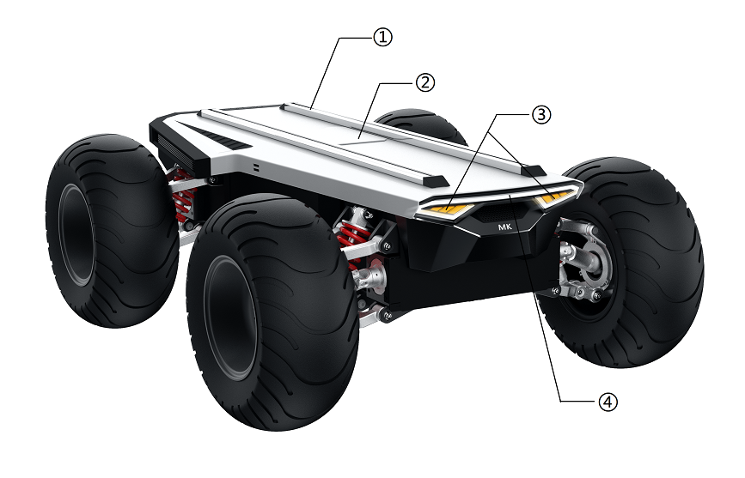

Clearance lamp

Aluminum extrusion rail

Electrical appliance compartment

Left and right turn signal lamp

Alarm indicator

Figure 4 - 1 Front Overall Figure

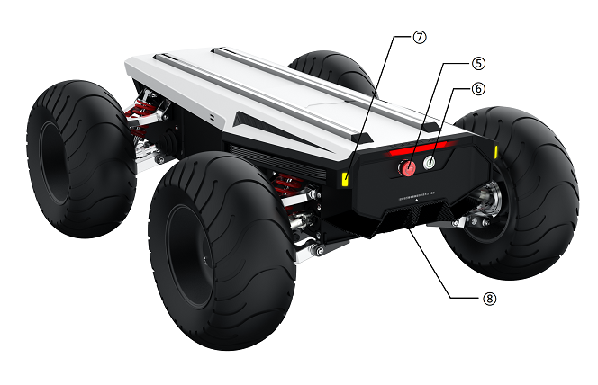

Left and right turn signal lamp

Power button

Charging interface

Emergancy stop button

Figure 4 - 2 Tail Overall Figure

Overall, MK ROBOT-02 uses the thought of modular design, resulting in high safety and reliability. In structure, it adopts differential drive steering structure, independent suspension and non-bearing vehicle body design make high vehicle body strength and high rigidity, so that the safety of the whole vehicle can be improved, bringing relatively strong impact resistance, and can pass through more complex ground environment.

Emergency stop switch is installed at the tail of the vehicle body. The vehicle can be stopped by beating the switch so as to avoid serious accident. Meanwhile, the emergency stop switch supports functional inspection. If the emergency stop switch is damaged or disconnection, VCU will take over and shut down the vehicle’s power; Multi-protection, guaranteeing safe driving of vehicles.

The vehicle body has multiple light control systems, including left and right turn signals, front clearance lights, alarm indicator, vehicle emergency deceleration warning lights, brake lights, vehicle operation breathing lights, fault indicator lights and other multiple indicator lights. During vehicle operation, it gives the maximum warning to pedestrians and vehicles to ensure the safe operation of robot. Customers can develop light control modes according to their personal needs.

MK ROBOT-02 adopts modular design concept; The vehicle drive controller --MCU, battery and battery management system (BMS) are integrated in the middle section of the vehicle body. The electric motors are integrated in front and rear sections of vehicle. The circuit group adopts the vehicle grade wiring harness and the connectors to ensure the stable operation and easy maintenance of the chassis.

The chassis is also equipped with integrated control. VCU analyzes and judges the vehicle signals uniformly, and forms closed-loop control, therefore, the faults can be diagnosed, and corresponding safety protection and processing can be conducted to reliably achieve unmanned vehicle status monitoring remotely. At the top of the vehicle body, there are electrical interfaces and communication interfaces of 48V, 24V and 12V. At the same time, the top is equipped with standard profile fixing support, so that the users can conduct secondary development quickly.

## 4.1. State indicator

Via voltage display on the remote controller and the starting sound, users can determine the status of the vehicle body. Refer to Figure 4-1 for details.

|  |  |
| --- | --- |
| **Status** | **Description** |
| Battery voltage | The current battery voltage of the vehicle body can be checked by sliding left the displayed on the remote controller (Figure 4-3). the percentage of the remaining battery can be known by checking Table 4-2 |
| Fault indicator | The fault status of the of the whole vehicle can be determined in accordance with the flashing frequency of the brake lamp under non-braking status and braking status. Once in 1S: level I fault alarm; Twice in 1S: level II fault alarm; Three times in 1S: level III fault alarm |

Table 4 - 1 Description of Vehicle Body Status

|  |  |  |  |  |  |  |  |  |  |  |
| --- | --- | --- | --- | --- | --- | --- | --- | --- | --- | --- |
| Comparison table for vehicle battery voltage and remaining percentage | | | | | | | | | | |
| Voltage (V) | 51.03 | 49.8 | 49.75 | 49.74 | 49.68 | 49.63 | 49.52 | 49.29 | 49.17 | 48.97 |
| SOC (%) | 100 | 95 | 90 | 85 | 80 | 75 | 70 | 65 | 60 | 55 |
| Voltage (V) | 48.96 | 48.95 | 48.91 | 48.82 | 48.65 | 48.45 | 48.19 | 47.83 | 47.53 | 42.65 |
| SOC (%) | 50 | 45 | 40 | 35 | 30 | 25 | 20 | 15 | 10 | 7 (Stop output) |

Table 3-2 Comparison Table for Vehicle Battery Voltage and SOC

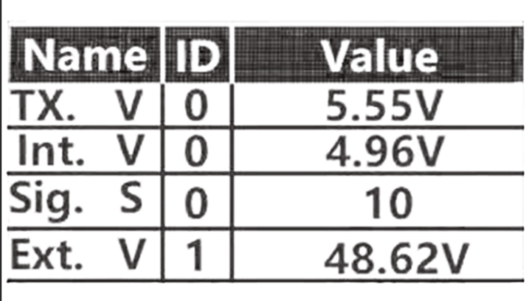

Figure 4-3 Interface of Vehicle Voltage on the Remote Controller

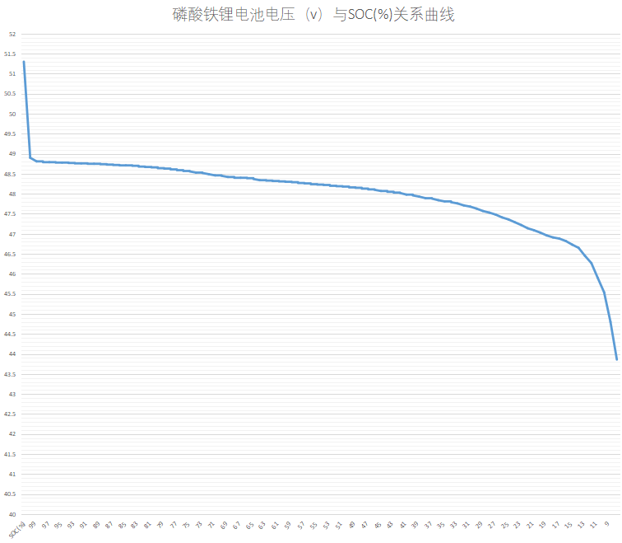

Figure 4-4 Relationship curve between battery voltage and SOC

Note:

① There is a certain deviation between the battery voltage and SOC. If the vehicle voltage is lower than 46V, please charge it in a timely manner and do not operate under low voltage condition.

② Fault level classification and handling method:

Level 1 fault: CAN signal and indicator light alarm;

Level 2 faults: CAN signal, indicator light alarm, and vehicle power reduction;

Level 3 faults: CAN signal, indicator light alarm, and driver power-off.

## 4.2. Instructions of electrical interface

MK Robot-02 is equipped with accessible power ports on the top. There are three DT06 plug-ins for 48V, 24V and 12V power supply, with corresponding power supply voltage labels. The red wire of the power supply plug-in is the positive pole, and the black is the negative pole. At the same time, a DB9 female connector is fixed in the electrical cabinet. The connector is for customer's secondary development. The pin definition is shown in Table 4-3. The corresponding power supply plug-in wires and DB9 plug-in wires have been prepared as shown in Figure 4-5, which is convenient for use to provide power for different expansion devices and communication.

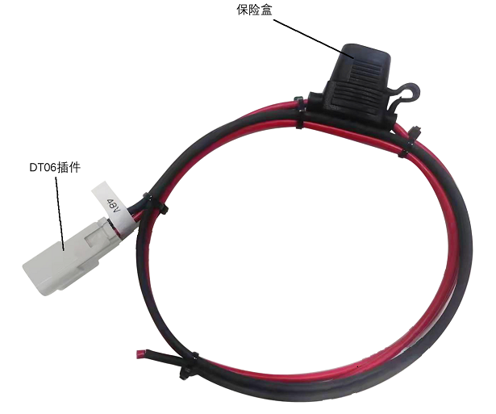

DT06 plug-in

Fuse Box

Figura 4-5 Power supply and communication wires

The specific pin definitions of top electrical interfaces are shown in Table 3-3 below

|  |  |  |  |  |
| --- | --- | --- | --- | --- |
| Plug-in | Pin | Type | Definition | Remark |
| DB9 | 1 | CAN | CAN_H | CAN bus - high |
| 2 | CAN_L | CAN bus - low |
| DT06 | 48V | Power supply | Red | Positive pole of 48V power supply |
| Black | GND |
| 24V | Red | Positive pole of 24V power supply |
| Black | GND |
| 12V | Red | Positive pole of 12V power supply |
| Black | GND |

Table 4-3 Pin Definitions of Top Electrical Interface

## 4.3. Remote controller instructions

The remote controllers have been paired before delivery, there is no need to modify the setups. Modification of remote controller setups without permission may lead to the problems of chaos in control and being out of control, etc. DO NOT modify the remote controller setups at will; In case of parameter faults, please contact our customer service or technical support. In case of modification, professional technicians are required for setting of remote controller.

### **4.3.1. Instructions of remote control**

Each MK Robot-02 is equipped with a FS-i6S remote controller. With this remote controller, users can easily control MK Robot-02. For FS-i6S remote controller of this product, we use the design of left-right steering by the left hand, forward-backward acceleration by right hand. At the same time, the knob is used to adjust the maximum speed of the accelerator by the right hand. Refer to Figure 4-6 for the definitions and functions.

Figure 4 -6 Schematic Diagram of FS-i6S Remote Controller Keys

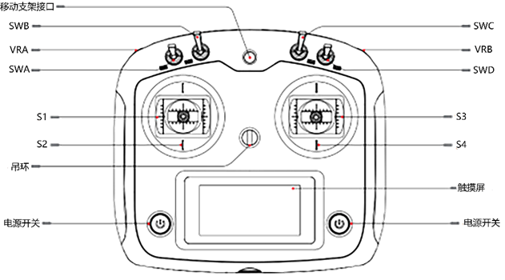

Touch screen

Power button

Power button

ring

The parameters of the remote controller have been configured before delivery. DO NOT modify the system configuration of the remote controller without permission, or, the robot may be out of control and in controlling chaos, etc. In case of any question, please contact the customer services or after-sales personnel for answering;

(1) SWA is the driving lever to switch the control mode. There are two control modes. For example, when the observe side of the remote controller is upward, and the driving lever of the SWA driving lever is upward, the control mode is remote controller control mode; when the SWA driving lever is downward, the control mode is command control mode;

(2) SWC is the high, medium and low speed controller of S3 rocker. For example, S3 rocker controls the vehicle to run in low speed mode when SWC is in the top position; S3 rocker controls the vehicle to run in medium speed mode when SWC is in the middle position; S3 rocker controls the vehicle to run in high speed mode when SWC is in the lowest position;

(3) The VRB is the operational protection dial and parking request dial. When operating the joystick, you need to simultaneously hold down the VRB dial. If you don't hold down the VRB dial, the chassis will not receive any motion commands from the joystick. This serves as a safety measure to prevent unintentional or unauthorized control of the vehicle. When the knob is turned up at once, a parking request is sent to activate the parking brake device; When the knob is turned down at once, a request is sent to release the parking brake;

(4) The left joystick is the direction control joystick. Joystick S1 controls the left and right steering of the chassis through its left and right movements. Joystick S2, when moved up or down, does not affect the chassis movement and is not currently in use. Its up and down movements have no impact on the chassis motion..

(5) The right joystick is the throttle control joystick. Joystick S4 controls the forward and backward movement of the chassis through its front and back movements. Joystick S3, when moved left or right, is not currently in use and does not affect the chassis movement. Its left and right movements have no impact on the chassis motion;

(6) There are power buttons on the left and right sides. By simultaneously long-pressing both power buttons, you can perform the power on/off operation.

### **4.3.2.** Instructions of remote controller buzzer alarm

|  |  |
| --- | --- |
| Switch position alarm | When the remote control is turned on and the lever switches SWA/SWB/SWC/SWD are not in their default positions, an alarm interface will appear, prompting the user to move all the switches to the upward position. Once all the switches are in their default positions, the main interface will appear normally. |
| Low voltage alarm | When the voltage drops below the alarm voltage, the system will emit an alarm, and the remote control screen will start flashing. If the voltage of the remote control is too low, the TX icon will flash, and if the voltage of the chassis is too low, the RX icon will flash. |
| Communication abnormal alarm | When the distance between the remote control and the chassis is too far or there is obstruction interference in the environment, the strength of the remote control signal will decrease. If the signal strength drops below 5, it will trigger a communication abnormal alarm, reminding the user that the remote control signal strength is weak. |
| Remote control unused alarm | When the remote control is unused for a long time, the remote control buzzer will emit intermittent alarms. |
| Power off alarm | When the remote control is turned off, it will check whether the chassis is also turned off. If the chassis is not turned off, a warning interface will pop up, and the chassis power must be turned off before the remote control can be turned off. (If it is necessary to force the remote control to shut down while the chassis is still on, the battery must be removed.) |

Table 4 -4 Instructions of Remote Controller Alarm Condition

### 

### **4.3.3.** Instructions of control commands and movement

In accordance with ISO 8855, we establish coordinate system as shown in Figure 4-7 for ground movement of the vehicle.

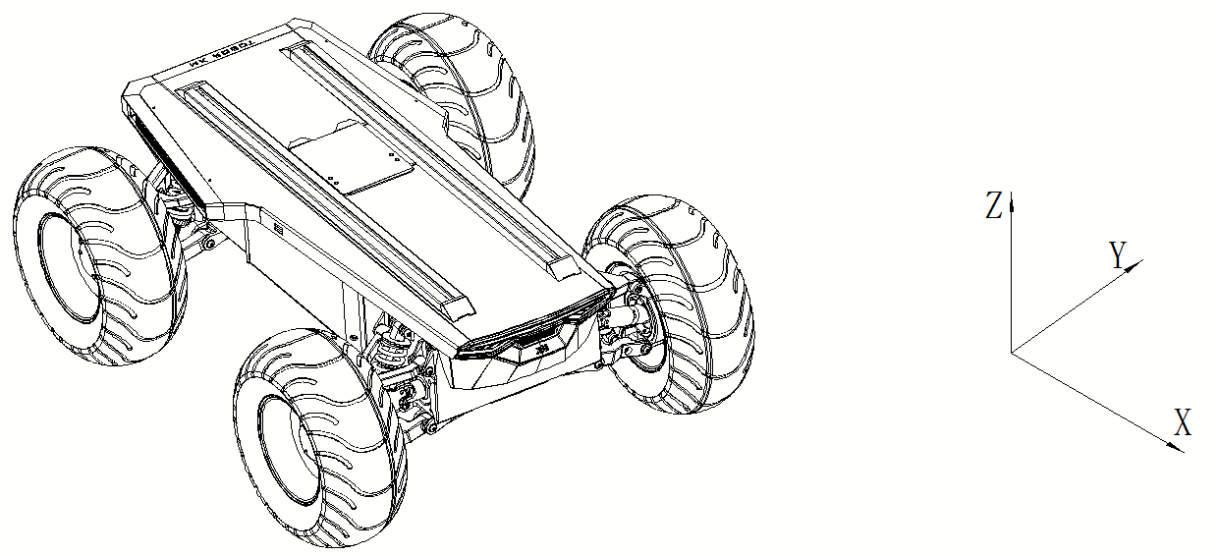

Figure 4 -7

As shown in Figure 4-7, the MK ROBOT-02 chassis is parallel to the X-axis of the established reference coordinate system.

In the remote controller control mode, while holding down the VRB (Vehicle Release Actuator) for operational protection, pushing the right-hand throttle joystick S3 forward on the remote controller will move the chassis in the positive X-direction. Pulling it backward will move the chassis in the negative X-direction. When the S3 joystick is pushed to its maximum value, the speed of movement in the X-direction is the highest. When pushed to its minimum value, the speed of movement in the negative X-direction is the highest.

The left-hand direction joystick S1 on the remote controller is used to control the steering movement of the chassis. When S1 is pushed to the left, the vehicle performs a differential steering to the left based on the high, medium, or low speed setting of the SWC (Steering Wheel Control). When pushed to the maximum, the left turning speed is the maximum angular velocity of the set mode (high, medium, or low speed). Similarly, when S1 is pushed to the right, the car performs a differential steering to the right based on the high, medium, or low speed setting of the SWC. When pushed to the maximum, the right turning speed is the maximum angular velocity of the set mode (high, medium, or low speed).

# 5. Getting started

This part mainly introduces the basic operation and use of MK Robot-02 platform, and how to conduct secondary development to the vehicle body through CAN bus protocol.

## 5.1. Use and operation

**The basic operations flow of remote operation are as follows:**

**Inspection**

(1) Check the status of the vehicle body. Check that whether the vehicle body has obvious abnormality; If any, please contact after-sales support;

(2) Check the status of the emergency stop button, and confirm that the emergency stop button at the tail is under the released state;

(3) Check that all gears of the remote controller are in neutral position;

**Start-up**

(1) Press B2 (starting switch)

(2) Check the vehicle battery voltage of the remote controller to see that whether the battery voltage is normal. If the voltage is lower than 47.5V, please charge first.

(3) Release the brake of the vehicle, switch to remote driving mode to observe that whether the brake lamp flashes and whether the vehicle is faulty. If there is any fault, connect to the CAN card to read the vehicle fault status and signal, and then, contact the after-sales personnel for solving.

**Close operation**

Press B2 (starting switch) again and release the switch to turn off the power supply;

**Emergency stop**

Beat the emergency stop switch on the electrical panel at the tail of MK Robot-02 vehicle body;

## 5.2. Charge

The chassis of the MK Robot-02 mobile robot is equipped with a 48V/5A charger in default, meeting the demands of charging of the users.

The specific operation processes of charging are as follows:

1) Before charging, please make sure that MK Robot-02 is shut down and powered off, and confirm that B2 (starting switch) on the electrical board at the tail is closed;

2) First, insert the output plug of the charger into the B1 charging interface on the electrical board at the tail; Then, plug the AC plug of the charger into the 220V AC socket.

3) After charging, operate in accordance with the reserve orders, unplug the AC plug first, and then, unplug the output plug.

4) The working status indicator of the charger is shown in Table 4-1.

Table 4 -1 Instructions of LED Indicator for Charger Status

|  |  |
| --- | --- |
| LED indicator light status | Charger status |
| LED1 is in bright red | The input line plug of the charger has been powered on |
| LED2 is in bright red | Indicating that the charger is charging |
| LED2 is in bright green | Indicating that the battery has been fully charged |

5) If the temperature of the charging environment is too high, the charger may enable temperature protection. Please move the charger to a cool or ventilated place for use, and resume normal charging when the internal temperature of the charger is lowered to 60°C. Refer to Table 4-2 for the instructions of charger protection status:

Table 4 -2 Instruction of Charger Protection Status

|  |  |
| --- | --- |
| **Protection function** | **Function description** |
| Over-heating protection | When the internal temperature of the charger reaches the over-temperature protection point, the charger stops charging automatically. |
| Output short-circuit protection | When the charger output is short-circuited unexpectedly, the charger turns off output automatically. |
| Output reverse connection protection | When the battery is connected in reverse, the charger will cut off the connection between the internal circuit and the battery. |
| Output over-voltage protection | When the output of the charger is over-voltage, the charger automatically turns off the output. |

Note:

When the vehicle is being charged, VCU will protect the charging state of the whole vehicle. If the vehicle is being charged when it is powered on, to ensure the charging safety, the vehicle will enable hydraulic braking and electromagnetic band-type parking brake. At the same time, the driver will be controlled to power off under high voltage. After charging, the driver will recover automatically. At the same time, the CAN signal will send the corresponding charging flag bit, and when necessary, if release is required, corresponding commands can be sent for release.

## 5.3. Development

MK Robot-02 product provides CAN interface to users for development, and users can conduct command control to the vehicle body with CAN interface.

### **5.3.1.** CAN interface protocol

The communication ofMK Robot-02 product is conducted by CAN2.0B extended frame, and the message format is Intel format with a baud rate of 500K. Through the external CAN bus interface, the vehicle speed, steering angle, brake pedal openness and parking request of the chassis can be controlled. The MK Robot-02 will feed back the current movement state information and the system state information of the MK Robot-02 chassis in real time.

The specific protocol contents are shown as below:

**The motion command control frame includes gear control, vehicle speed control, steering angle control, brake pedal opening, parking request and inspection, etc. The specific protocol contents are shown in Table 4-3. Refer to 4.3.2 for wiring instructions, and 4.3.3 for CAN communication transmission requirements and test examples.**

Note: The CAN interface is a non-isolated interface. During use, please prevent the CAN line from being wrongly connected or prevent the CAN bus from being connected with the power line of the given type. In case of connection, VCU may be burned out.

CAN protocol is shown as below:

Baud rate: 500K

Table 4-3 Command Control Frame and System Feedback Frame

|  |  |  |  |  |  |  |  |  |  |
| --- | --- | --- | --- | --- | --- | --- | --- | --- | --- |
| **Message name** | | | **ID** | | | | **Cycle**  **(ms)** | | **(Byte)**  **Message length** |
| ctrl_DGT_cmd | | | 0x18C4D1D0 | | | | 10 | | 8 |
| **Signal description** | **Arrangement format** | **Starting byte** | **Start bit** | **Signal duration** | **Data type** | **Precision** | **Offset** | **Unit** | **Signal value description** |
| Target gear | Intel | 0 | 0 | 4 | Unsigned | 1 | 0 |  | 01: Gear P  04: Free control gear  The remaining values are invalid, and enter the parking gear by default  (Only when 0x18C4D2D0 and 0x18C4D3D0 are online at the same time and both gears are in 04: free control gear, will respond first when 0x18C4D1D0 is online 03: four-wheel differential kinematics control gear) |
| Target vehicle speed | Intel | 0 | 4 | 16 | Unsigned | 0.001 | 0 | m/s | 0.001m/s/bit； |
| Target vehicle angular speed | Intel | 2 | 20 | 16 | signed | 0.01 | 0 | °/s | (0.01°/s)/bit； |
| Alive Rolling Counter  Heartbeat signal (loop counter) | Intel | 6 | 52 | 4 | Unsigned | 1 | 0 |  | For each sent frame, the value will increase by 1, after the maximum value is reached, the value will be reset to 0 to check packet loss and disconnection |
| Check BCC  XOR checkout for message | Intel | 7 | 56 | 8 | Unsigned | 1 | 0 |  | Checksum = Byte0 XOR Byte1 XOR Byte2 XOR Byte3 XOR Byte4 XOR Byte5 XOR Byte6 |
| **Message name** | | | **ID** | | | | **Cycle**  **(ms)** | | **(Byte)**  **Message length** |
| front_free_ctrl_cmd | | | 0x18C4D2D0 | | | | 10 | | 8 |
| **Signal description** | **Arrangement format** | **Starting byte** | **Start bit** | **Signal duration** | **Data type** | **Precision** | **Offset** | **Unit** | **Signal value description** |
| Target gear | Intel | 0 | 0 | 4 | Unsigned | 1 | 0 |  | 01: Gear P  04: Free control gear  The remaining values are invalid, and enter the parking gear by default  (Only when 0x18C4D2D0 and 0x18C4D3D0 are online at the same time and both gears are in 04: free control gear, will respond first when 0x18C4D1D0 is online 03: four-wheel differential kinematics control gear) |
| Target speed of front left wheel | Intel | 0 | 4 | 16 | signed | 0.001 | 0 | m/s | 0.001m/s/bit； |
| Target speed of front right wheel | Intel | 2 | 20 | 16 | signed | 0.001 | 0 | m/s | 0.001m/s/bit |
| Alive Rolling Counter  Heartbeat signal (loop counter) | Intel | 6 | 52 | 4 | Unsigned | 1 | 0 |  | For each sent frame, the value will increase by 1, after the maximum value is reached, the value will be reset to 0 to check packet loss and disconnection |
| Check BCC  XOR checkout for message | Intel | 7 | 56 | 8 | Unsigned | 1 | 0 |  | Checksum = Byte0 XOR Byte1 XOR Byte2 XOR Byte3 XOR Byte4 XOR Byte5 XOR Byte6 |
| **Message name** | | | **ID** | | | | **Cycle**  **(ms)** | | **(Byte)**  **Message length** |
| rear_free_ctrl_cmd | | | 0x18C4D3D0 | | | | 10 | | 8 |
| **Signal description** | **Arrangement format** | **Starting byte** | **Start bit** | **Signal duration** | **Data type** | **Precision** | **Offset** | **Unit** | **Signal value description** |
| Target gear | Intel | 0 | 0 | 4 | Unsigned | 1 | 0 |  | 01: Gear P  04: Free control gear  The remaining values are invalid, and enter the parking gear by default  (Only when 0x18C4D2D0 and 0x18C4D3D0 are online at the same time and both gears are in 04: free control gear, will respond first when 0x18C4D1D0 is online 03: four-wheel differential kinematics control gear) |
| Target speed of rear left wheel | Intel | 0 | 4 | 16 | signed | 0.001 | 0 | m/s | 0.001m/s/bit； |
| Target speed of rear right wheel | Intel | 2 | 20 | 16 | signed | 0.001 | 0 | m/s | 0.001m/s/bit |
| Alive Rolling Counter  Heartbeat signal (loop counter) | Intel | 6 | 52 | 4 | Unsigned | 1 | 0 |  | For each sent frame, the value will increase by 1, after the maximum value is reached, the value will be reset to 0 to check packet loss and disconnection |
| Check BCC  XOR checkout for message | Intel | 7 | 56 | 8 | Unsigned | 1 | 0 |  | Checksum = Byte0 XOR Byte1 XOR Byte2 XOR Byte3 XOR Byte4 XOR Byte5 XOR Byte6 |
| **Message name** | | | **ID** | | | | **Cycle**  **(ms)** | | **(Byte)**  **Message length** |
| io_cmd | | | 0x18C4D7D0 | | | | 50 | | 8 |
| **Signal description** | **Arrangement format** | **Starting byte** | **Start bit** | **Signal**  **Length** | **Data type** | **Precision** | **Offset** | **Unit** | **Signal value description** |
| I/O control enable | Intel | 0 | 0 | 1 | Unsigned | 1 | 0 |  | 0=off: turn signal lamp and clearance lamp are controlled by VCU  1=on: turn signal and clearance lamp are controlled by CAN signal |
| Turn signal and alarm indicator switch | Intel | 1 | 10 | 2 | Unsigned | 1 | 0 |  | 0=off  1=left turn signal lamp on  2=right turn signal lamp off  3=alarm indicator (turn signal priority is higher than alarm indicator) |
| Clearance lamp switch | Intel | 1 | 13 | 1 | Unsigned | 1 | 0 |  | 0=off  1=on |
| Forced power-on flag bit when charging | Intel | 5 | 40 | 1 | Unsigned | 1 | 0 |  | When the vehicle is forced to be enabled under the charging state, the flag bit can control the 48V high voltage of the vehicle to be powered on, and the vehicle can resume the driving control, and the flag bit can enable the vehicle to not reverse under the charging state. |
| Alive Rolling Counter  Heartbeat signal (loop counter) | Intel | 6 | 52 | 4 | Unsigned | 1 | 0 |  | For each sent frame, the value will increase by 1, after the maximum value is reached, the value will be reset to 0 to check packet loss and disconnection |
| Check BCC  XOR checkout for message | Intel | 7 | 56 | 8 | Unsigned | 1 | 0 |  | Checksum = Byte0 XOR Byte1 XOR Byte2 XOR Byte3 XOR Byte4 XOR Byte5 XOR Byte6 |
| **Message name** | | | **ID** | | | | **Cycle**  **(ms)** | | **(Byte)**  **Message length** |
| ctrl_DGT_fb | | | 0x18C4D1EF | | | | 10 | | 8 |
| **Signal description** | **Arrangement format** | **Starting byte** | **Start bit** | **Signal duration** | **Data type** | **Precision** | **Offset** | **Unit** | **Signal value description** |
| Target gear | Intel | 0 | 0 | 4 | Unsigned | 1 | 0 |  | 00: disable  01: Gear P  02：Gear R  03: Kinematic control  04: Free control  Other data is invalid, default as parking |
| Current vehicle linear speed feedback | Intel | 0 | 4 | 16 | signed | 0.001 | 0 | m/s | 0.001m/s/bit； |
| Current vehicle angular speed feedback | Intel | 2 | 20 | 16 | signed | 0.01 | 0 | °/s | (0.01°/s)/bit； |
| Current vehicle operation mode feedback | Intel | 5 | 44 | 2 | Unsigned | 1 | 0 |  | 0x0：auto  0x1：remote  0x2：stop |
| Alive Rolling Counter  Heartbeat signal (loop counter) | Intel | 6 | 52 | 4 | Unsigned | 1 | 0 |  | For each sent frame, the value will increase by 1, after the maximum value is reached, the value will be reset to 0 to check packet loss and disconnection |
| Check BCC  XOR checkout for message | Intel | 7 | 56 | 8 | Unsigned | 1 | 0 |  | Checksum = Byte0 XOR Byte1 XOR Byte2 XOR Byte3 XOR Byte4 XOR Byte5 XOR Byte6 |
| **Message name** | | | **ID** | | | | **Cycle**  **(ms)** | | **(Byte)**  **Message length** |
| lf_wheel_fb | | | 0x18C4D6EF | | | | 10 | | 8 |
| **Signal description** | **Arrangement format** | **Starting byte** | **Start bit** | **Signal duration** | **Data type** | **Precision** | **Offset** | **Unit** | **Signal value description** |
| Current left front wheel speed feedback | Intel | 0 | 0 | 16 | signed | 0.001 | 0 | m/s | 0.001m/s/bit； |
| Current left front wheel pulse feedback | Intel | 2 | 16 | 32 | signed | 1 | 0 |  | 350000 pulses per wheel, 2500 lines of encoder, 4 times frequency, 35 reduction. |
| Alive Rolling Counter  Heartbeat signal (loop counter) | Intel | 6 | 52 | 4 | Unsigned | 1 | 0 |  | For each sent frame, the value will increase by 1, after the maximum value is reached, the value will be reset to 0 to check packet loss and disconnection |
| Check BCC  XOR checkout for message | Intel | 7 | 56 | 8 | Unsigned | 1 | 0 |  | Checksum = Byte0 XOR Byte1 XOR Byte2 XOR Byte3 XOR Byte4 XOR Byte5 XOR Byte6 |
| **Message name** | | | **ID** | | | | **Cycle**  **(ms)** | | **(Byte)**  **Message length** |
| lr_wheel_fb | | | 0x18C4D7EF | | | | 10 | | 8 |
| **Signal description** | **Arrangement format** | **Starting byte** | **Start bit** | **Signal**  **Length** | **Data type** | **Precision** | **Offset** | **Unit** | **Signal value description** |
| Current left rear wheel speed feedback | Intel | 0 | 0 | 16 | signed | 0.001 | 0 | m/s | 0.001m/s/bit； |
| Current left rear wheel pulse number feedback | Intel | 2 | 16 | 32 | signed | 1 | 0 |  | 350000 pulses per wheel, 2500 lines of encoder, 4 times frequency, 35 reduction. |
| Alive Rolling Counter  Heartbeat signal (loop counter) | Intel | 6 | 52 | 4 | Unsigned | 1 | 0 |  | For each sent frame, the value will increase by 1, after the maximum value is reached, the value will be reset to 0 to check packet loss and disconnection |
| Check BCC  XOR checkout for message | Intel | 7 | 56 | 8 | Unsigned | 1 | 0 |  | Checksum = Byte0 XOR Byte1 XOR Byte2 XOR Byte3 XOR Byte4 XOR Byte5 XOR Byte6 |
| **Message name** | | | **ID** | | | | **Cycle**  **(ms)** | | **(Byte)**  **Message length** |
| rr_wheel_fb | | | 0x18C4D8EF | | | | 10 | | 8 |
| **Signal description** | **Arrangement format** | **Starting byte** | **Start bit** | **Signal duration** | **Data type** | **Precision** | **Offset** | **Unit** | **Signal value description** |
| Current right rear wheel speed feedback | Intel | 0 | 0 | 16 | signed | 0.001 | 0 | m/s | 0.001m/s/bit； |
| Current right rear wheel pulse number feedback | Intel | 2 | 16 | 32 | signed | 1 | 0 | 1 | 350000 pulses per wheel, 2500 lines of encoder, 4 times frequency, 35 reduction. |
| Alive Rolling Counter  Heartbeat signal (loop counter) | Intel | 6 | 52 | 4 | Unsigned | 1 | 0 |  | For each sent frame, the value will increase by 1, after the maximum value is reached, the value will be reset to 0 to check packet loss and disconnection |
| Check BCC  XOR checkout for message | Intel | 7 | 56 | 8 | Unsigned | 1 | 0 |  | Checksum = Byte0 XOR Byte1 XOR Byte2 XOR Byte3 XOR Byte4 XOR Byte5 XOR Byte6 |
| **Message name** | | | **ID** | | | | **Cycle**  **(ms)** | | **(Byte)**  **Message length** |
| rf_wheel_fb | | | 0x18C4D9EF | | | | 10 | | 8 |
| **Signal description** | **Arrangement format** | **Starting byte** | **Start bit** | **Signal duration** | **Data type** | **Precision** | **Offset** | **Unit** | **Signal value description** |
| Current right front wheel speed feedback | Intel | 0 | 0 | 16 | signed | 0.001 | 0 | m/s | 0.001m/s/bit； |
| Current right front wheel pulse number feedback | Intel | 2 | 16 | 32 | signed | 1 | 0 | 1 | 350000 pulses per wheel, 2500 lines of encoder, 4 times frequency, 35 reduction. |
| Alive Rolling Counter  Heartbeat signal (loop counter) | Intel | 6 | 52 | 4 | Unsigned | 1 | 0 |  | For each sent frame, the value will increase by 1, after the maximum value is reached, the value will be reset to 0 to check packet loss and disconnection |
| Check BCC  XOR checkout for message | Intel | 7 | 56 | 8 | Unsigned | 1 | 0 |  | Checksum = Byte0 XOR Byte1 XOR Byte2 XOR Byte3 XOR Byte4 XOR Byte5 XOR Byte6 |
| **Message name** | | | **ID** | | | | **Cycle**  **(ms)** | | **(Byte)**  **Message length** |
| io_fb | | | 0x18C4DAEF | | | | 50 | | 8 |
| **Signal description** | **Arrangement format** | **Starting byte** | **Start bit** | **Signal duration** | **Data type** | **Precision** | **Offset** | **Unit** | **Signal value description** |
| I/O control enabling feedback | Intel | 0 | 0 | 1 | Unsigned | 1 | 0 |  | 0=off  1=on |
| Turn signal switch status feedback | Intel | 1 | 10 | 2 | Unsigned | 1 | 0 |  | 0=off  1=left turn signal lamp on  2=right turn signal lamp on  3=alarm indicator |
| Brake light switch status feedback | Intel | 1 | 12 | 1 | Unsigned | 1 | 0 |  | 0=off  1=on |
| Charging forced power-on flag bit | Intel | 5 | 40 | 1 | Unsigned | 1 | 0 |  | When the vehicle is forced to be enabled under the charging state, the flag bit can control the 48V high voltage of the vehicle to be powered on, and the vehicle can resume the driving control, and the flag bit can enable the vehicle to not reverse under the charging state. |
| Charge pile and vehicle contact enable flag bit | Intel | 5 | 41 | 1 | Unsigned | 1 | 0 |  | When the vehicle is in the backward state, the VCU charging detection IO port is triggered when the charging pile contacts the vehicle |
| Alive Rolling Counter  Heartbeat signal (loop counter) | Intel | 6 | 52 | 4 | Unsigned | 1 | 0 |  | For each sent frame, the value will increase by 1, after the maximum value is reached, the value will be reset to 0 to check packet loss and disconnection |
| Check BCC  XOR checkout for message | Intel | 7 | 56 | 8 | Unsigned | 1 | 0 |  | Checksum = Byte0 XOR Byte1 XOR Byte2 XOR Byte3 XOR Byte4 XOR Byte5 XOR Byte6 |
| **Message name** | | | **ID** | | | | **Cycle**  **(ms)** | | **(Byte)**  **Message length** |
| odo_fb | | | 0x18C4DEEF | | | | 10 | | 8 |
| **Signal description** | **Arrangement format** | **Starting byte** | **Start bit** | **Signal duration** | **Data**  **Type** | **Precision** | **Offset** | **Unit** | **Signal value description** |
| Accumulated mileage | Intel | 0 | 0 | 32 | signed | 0.001 | 0 | m | 0.001m/bit |
| Accumulated angule(reserved) | Intel | 4 | 32 | 32 | signed | 0.001 | 0 | rad | 0.001rad/bit |
| **Message name** | | | **ID** | | | | **Cycle**  **(ms)** | | **(Byte)**  **Message length** |
| bms_Infor | | | 0x18C4E1EF | | | | 10 | | 8 |
| **Signal description** | **Arrangement format** | **Starting byte** | **Start bit** | **Signal duration** | **Data**  **Type** | **Precision** | **Offset** | **Unit** | **Signal value description** |
| Current battery voltage | Intel | 0 | 0 | 16 | Unsigned | 0.01 | 0 | V | 0.01V/bit; |
| Current battery current | Intel | 2 | 16 | 16 | signed | 0.01 | 0 | A | 0.01A/bit; |
| Current battery remaining capacity | Intel | 4 | 32 | 16 | Unsigned | 0.01 | 0 | Ah | 0.01Ah/bit; |
| Alive Rolling Counter  Heartbeat signal (loop counter) | Intel | 6 | 52 | 4 | Unsigned | 1 | 0 |  | For each sent frame, the value will increase by 1, after the maximum value is reached, the value will be reset to 0 to check packet loss and disconnection |
| Check BCC  XOR checkout for message | Intel | 7 | 56 | 8 | Unsigned | 1 | 0 |  | Checksum = Byte0 XOR Byte1 XOR Byte2 XOR Byte3 XOR Byte4 XOR Byte5 XOR Byte6 |
| **Message name** | | | **ID** | | | | **Cycle**  **(ms)** | | **(Byte)**  **Message length** |
| bms_flag_Infor | | | 0x18C4E2EF | | | | 100 | | 8 |
| **Signal description** | **Arrangement format** | **Starting byte** | **Start bit** | **Signal duration** | **Data**  **Type** | **Precision** | **Offset** | **Unit** | **Signal value description** |
| Current percentage of remaining battery capacity | Intel | 0 | 0 | 8 | Unsigned | 1 | 0 | % | 1%/bit; |
| Monomer overvoltage protection | Intel | 1 | 8 | 1 | Unsigned | 1 | 0 |  | 0 = off  1 = on |
| Monomer undervoltage protection | Intel | 1 | 9 | 1 | Unsigned | 1 | 0 |  | 0 = off  1 = on |
| Over-voltage protection of the whole group | Intel | 1 | 10 | 1 | Unsigned | 1 | 0 |  | 0 = off  1 = on |
| Under-voltage protection of the whole group | Intel | 1 | 11 | 1 | Unsigned | 1 | 0 |  | 0 = off  1 = on |
| Charging over-temperature protection | Intel | 1 | 12 | 1 | Unsigned | 1 | 0 |  | 0 = off  1 = on |
| Charging low-temperature protection | Intel | 1 | 13 | 1 | Unsigned | 1 | 0 |  | 0 = off  1 = on |
| Discharge over-temperature protection | Intel | 1 | 14 | 1 | Unsigned | 1 | 0 |  | 0 = off  1 = on |
| Discharge low-temperature protection | Intel | 1 | 15 | 1 | Unsigned | 1 | 0 |  | 0 = off  1 = on |
| Charging overcurrent protection | Intel | 2 | 16 | 1 | Unsigned | 1 | 0 |  | 0 = off  1 = on |
| Discharge overcurrent protection | Intel | 2 | 17 | 1 | Unsigned | 1 | 0 |  | 0 = off  1 = on |
| Short circuit protection | Intel | 2 | 18 | 1 | Unsigned | 1 | 0 |  | 0 = off  1 = on |
| Front-end detection IC error | Intel | 2 | 19 | 1 | Unsigned | 1 | 0 |  | 0 = off  1 = on |
| Software locks up MOS | Intel | 2 | 20 | 1 | Unsigned | 1 | 0 |  | 0 = off  1 = on |
| Charging status | Intel | 2 | 21 | 2 | Unsigned | 1 | 0 |  | 0=uncharge  1=manual charging  2=Charging of front charging pile  3=Charging of rear charging pile |
| Low SOC alarm | Intel | 2 | 23 | 1 | Unsigned | 1 | 0 |  | 0 = normal  1 = low |
| Low battery capacity alarm | Intel | 2 | 24 | 1 | Unsigned | 1 | 0 |  | 0 = normal  1 = low |
| Current maximum temperature of battery | Intel | 1 | 28 | 12 | signed | 0.1 | 0 | ℃ | 0.1℃/bit； |
| Current minimum temperature of battery | Intel | 1 | 40 | 12 | signed | 0.1 | 0* | ℃ | 0.1℃/bit； |
| Alive Rolling Counter  Heartbeat signal (loop counter) | Intel | 6 | 52 | 4 | Unsigned | 1 | 0 |  | For each sent frame, the value will increase by 1, after the maximum value is reached, the value will be reset to 0 to check packet loss and disconnection |
| Check BCC  XOR checkout for message | Intel | 7 | 56 | 8 | Unsigned | 1 | 0 |  | Checksum = Byte0 XOR Byte1 XOR Byte2 XOR Byte3 XOR Byte4 XOR Byte5 XOR Byte6 |
| **Message name** | | | **ID** | | | | **Cycle**  **(ms)** | | **(Byte)**  **Message length** |
| Veh_fb_Diag | | | 0x18C4EAEF | | | | 10 | | 8 |
| **Signal description** | **Arrangement format** | **Starting byte** | **Start bit** | **Signal duration** | **Data**  **Type** | **Precision** | **Offset** | **Unit** | **Signal value description** |
| Vehicle fault level | Intel | 0 | 0 | 4 | Unsigned | 1 | 0 |  | 0: no fault  1: level 1 fault  2: level 2 fault  3: level 3 fault  Others are invalid |
| Auto control CAN communication error | Intel | 0 | 4 | 1 | Unsigned | 1 | 0 |  | 0 = normal  1 = fault |
| Auto IO control CAN communication error | Intel | 0 | 5 | 1 | Unsigned | 1 | 0 |  | 0 = normal  1 = fault |
| EPS offline fault | Intel | 1 | 8 | 1 | Unsigned | 1 | 0 |  | 0 = normal  1 = fault |
| EPS fault | Intel | 1 | 9 | 1 | Unsigned | 1 | 0 |  | 0 = normal  1 = fault |
| EPS MOSFET over temperature | Intel | 1 | 10 | 1 | Unsigned | 1 | 0 |  | 0 = normal  1 = fault |
| EPS fault alarm | Intel | 1 | 11 | 1 | Unsigned | 1 | 0 |  | 0 = normal  1 = fault |
| EPS work fault | Intel | 1 | 12 | 1 | Unsigned | 1 | 0 |  | 0 = normal  1 = fault |
| EPS over current fault | Intel | 1 | 13 | 1 | Unsigned | 1 | 0 |  | 0 = normal  1 = fault |
| Left front wheel motor drive fault | Intel | 2 | 20 | 6 | Unsigned | 1 | 0 |  | Refer to Note: Vehicle fault status feedback note ① |
| right front wheel motor drive fault | Intel | 3 | 26 | 6 | Unsigned | 1 | 0 |  | Refer to Note: Vehicle fault status feedback note ① |
| Left rear wheel motor drive fault | Intel | 4 | 32 | 6 | Unsigned | 1 | 0 |  | Refer to Note: Vehicle fault status feedback note ① |
| Right rear wheel motor drive fault | Intel | 4 | 38 | 6 | Unsigned | 1 | 0 |  | Refer to Note: Vehicle fault status feedback note ① |
| BMS CAN communication disconnection fault | Intel | 5 | 44 | 1 | Unsigned | 1 | 0 |  | 0 = normal  1 = fault |
| Emergancy stop fault | Intel | 5 | 45 | 1 | Unsigned | 1 | 0 |  | 0 = on  1 = off |
| Remote controller turn off alarm | Intel | 5 | 46 | 1 | Unsigned | 1 | 0 |  | 0 = normal  1 = fault |
| Remote control receiver disconnection fault | Intel | 5 | 47 | 1 | Unsigned | 1 | 0 |  | 0 = normal  1 = fault |
| Alive Rolling Counter  Heartbeat signal (loop counter) | Intel | 6 | 52 | 4 | Unsigned | 1 | 0 |  | For each sent frame, the value will increase by 1, after the maximum value is reached, the value will be reset to 0 to check packet loss and disconnection |
| Check BCC  XOR checkout for message | Intel | 7 | 56 | 8 | Unsigned | 1 | 0 |  | Checksum = Byte0 XOR Byte1 XOR Byte2 XOR Byte3 XOR Byte4 XOR Byte5 XOR Byte6 |

Note①: Left front wheel motor drive fault, right front wheel motor drive fault, left rear wheel motor drive fault, right rear wheel motor drive fault signal description

|  |  |  |  |
| --- | --- | --- | --- |
| **Note_Signal_Value** | **Note_Signal_Name** | **Note_Signal_Description** | **Failure_level** |
| 0x00 |  | No fault of motor drive | 0 |
| 0x01 | DiagMCU_DisOnlie | Motor drive CAN communication signal is disconnected | 3 |
| 0x02 | DiagMCU_EbrSL | The discharge resistance value of motor drive is too small | 2 |
| 0x03 | DiagSCMCU_EcoUt | Motor drive communication timeout | 3 |
| 0x04 | DiagSCMCU_EcotS | Motor drive offline stop | 3 |
| 0x05 | DiagSCMCU_EcStp | Motor drive autonomous stop | 3 |
| 0x06 | DiagSCMCU_EdnRE | Motor drive no response error alarm | 3 |
| 0x07 | DiagSCMCU_EEnAb | Motor drive encoder AB signal alarm | 2 |
| 0x08 | DiagSCMCU_Eencu | Motor drive encoder UVW signal alarm | 2 |
| 0x09 | DiagSCMCU_EFrAE | Motor drive FRAM data write operation verification error | 3 |
| 0x0A | DiagSCMCU_EGEAr | Motor drive abnormal parameters of electronic gear | 3 |
| 0x0B | DiagSCMCU_ELUdc | Motor drive undervoltage alarm | 2 |
| 0x0C | DiagSCMCU_EocA | Motor drive phase A overcurrent alarm | 2 |
| 0x0D | DiagSCMCU_EocB | Motor drive phase B overcurrent alarm | 2 |
| 0x0E | DiagSCMCU_EocC | Motor drive phase C overcurrent alarm | 2 |
| 0x0F | DiagSCMCU_EoLoad | Motor drive overload alarm | 2 |
| 0x10 | DiagSCMCU_EoSPE | Motor exceeding maximum speed alarm | 2 |
| 0x11 | DiagSCMCU_EoUdc | Motor drive overvoltage alarm | 2 |
| 0x12 | DiagSCMCU_EoUP | Motor drive abnormal phase voltage alarm | 2 |
| 0x13 | DiagSCMCU_EPArA | Motor drive FRAM parameter overflow error | 3 |
| 0x14 | DiagSCMCU_EorEr | Motor drive zeroing timeout alarm | 3 |
| 0x15 | DiagSCMCU_EPEOU | Motor drive position deviation counter overflow | 2 |
| 0x16 | DiagSCMCU_Ehot | Over-temperature of power component of motor drive | 2 |
| 0x17 | DiagSCMCU_EPosE | Motor drive position out-of-tolerance alarm | 2 |
| 0x18 | DiagSCMCU_EPS1E | Motor drive 1 phase current ADC zero point abnormal alarm | 3 |
| 0x19 | DiagSCMCU_EPS2E | Motor drive 2 phase current ADC zero abnormal alarm | 3 |
| 0x1A | DiagSCMCU_ESPEE | Motor drive exceed speed alarm | 3 |
| 0x1B | DiagSCMCU_EUSPn | Motor not compliance alarm | 3 |
| 0x1C | DiagSCMCU_E2LoS | Motor encoder Z pulse loss fault alarm | 3 |
| 0x1D | DiagSCMCU_E2EtE | motor encoder Z pulse excessive fault alarm | 3 |

### **5.3.2.** CAN wire connection

CAN wires of MK Robot-02 have been welded out and marked, and users can directly connect them in accordance with the marks, as shown in Figure 4-1 below

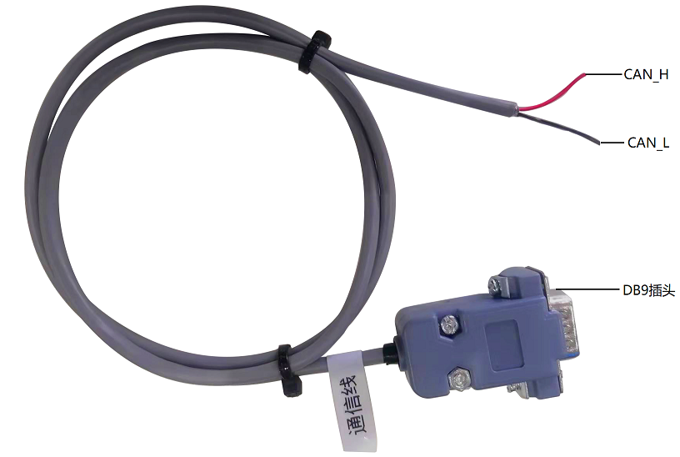

Figure 4-1 Schematic Diagram of CAN Wire Position

Red is CAN_H; Black is CAN_L

### **5.3.3.** **Instructions of use of common VCU protocol**

**1. Attentions during test:**

1.1 During transmission, it shall be noted that, AliveCounter requires for continuous change and cycled transmission.

1.2 During transmission of AliveCounter, it shall be specially noted that, AliveCounter occupies four bits from No. 52 to No. 55.

1.3 BYTE[7] parity bit is the first 7 Byte XOR gates: Checksum = Byte0 XOR Byte1 XOR Byte2 XOR Byte3 XOR Byte4 XOR Byte5 XOR Byte6

1.4 The following routine is a simple control command when USB CAN is used. Please control the vehicle in accordance with the communication protocol.

1.5 During the test, the remote controller is switched to automatic driving mode or turned off.

1.6 As the vehicle movement and other conditions may be tested during test by connecting to computer via CAN analyzer, please set up the vehicle during test, and after the vehicle is stably tested, put the vehicle down.

1.7 During the landing test, as the remote controller has the highest priority, it is best to turn on the remote controller for testing, facilitating to switch to the remote control mode at any time during the test.

**2. Instructions of vehicle control command ctrl_cmd**

For vehicle body control command, it is required to transmit corresponding commands, heartbeat signals and parity bits.

**(1) Targeted gear request ctrl_cmd_gear**

The command of ctrl_cmd_gear is targeted gear signal, with a physical value range of 01-04. In default, 01 is Gear P for braking;When the target gear is set as 03, it is kinematic analytical control.

For example: When target gear requests for drive gear, -03 0x03

|  |  |  |  |  |  |  |  |  |
| --- | --- | --- | --- | --- | --- | --- | --- | --- |
| ID | D[0] | D[1] | D[2] | D[3] | D[4] | D[5] | D[6] | D[7] |
| 0x18C4D1D0 | 0x03 | 0x00 | 0x00 | 0x00 | 0x00 | 0x00 | 0x10 | 0x13 |
| 0x18C4D1D0 | 0x03 | 0x00 | 0x00 | 0x00 | 0x00 | 0x00 | 0x20 | 0x23 |
| 0x18C4D1D0 | 0x03 | 0x00 | 0x00 | 0x00 | 0x00 | 0x00 | 0x30 | 0x33 |

Note: The above three frames of signals are circulated at an interval of 10ms, and the gear can be controlled to be switched to the kinematic analytical gear.

Feedback:

|  |  |  |  |  |  |  |  |  |
| --- | --- | --- | --- | --- | --- | --- | --- | --- |
| ID | D[0] | D[1] | D[2] | D[3] | D[4] | D[5] | D[6] | D[7] |
| 0x18C4D1EF | 0x03 | 0x00 | 0x00 | 0x00 | 0x00 | 0x00 | 0x00 | 0x03 |

Note: Checkout and cyclic change of Alivecounter

**(2) Target vehicle speed request ctrl_cmd_linear**

The command of ctrl_cmd_velocity is the target value of vehicle speed, and the physical value range of CAN communication is -32.768 -32.767m/s (35 speed ratio, and the maximum vehicle speed of the vehicle with a wheel diameter of 324mm is 1.5m/s). The target vehicle speed is determined by vehicle speed precision (0.001m/s/bit). Target vehicle speed driving vehicle = 0.001* bus signal Forward and backward movement of vehicle shall be conducted in accordance with the gears.

Vehicle speed feedback is divided into three methods, they are:

1. Current vehicle speed feedback: The speed feedback is the linear speed of four wheels, which is derived from the differential kinematics model of four wheels.

2) Left and right wheel speed and vehicle speed feedback: It is the current vehicle speed corresponding to left and right wheels, during forward movement, the vehicle speed is positive, and when the backward movement is negative.

3) Left and right wheel pulse count feedback: Forward movement is the accumulation of pulse count, and backward movement is the accumulative decrease of pulse count.

For example: When the given forward movement vehicle speed is 1m/s, the bus signal is 1000 0x03EB

|  |  |  |  |  |  |  |  |  |
| --- | --- | --- | --- | --- | --- | --- | --- | --- |
| ID | D[0] | D[1] | D[2] | D[3] | D[4] | D[5] | D[6] | D[7] |
| 0x18C4D1D0 | 0x83 | 0x3E | 0x01 | 0x00 | 0x00 | 0x00 | 0x00 | 0xBD |
| 0x18C4D1D0 | 0x83 | 0x3E | 0x01 | 0x00 | 0x00 | 0x00 | 0x10 | 0xAD |
| 0x18C4D1D0 | 0x83 | 0x3E | 0x01 | 0x00 | 0x00 | 0x00 | 0x20 | 0x9D |

Note: The above three frames of signals are circulated at an interval of 10ms, so that the vehicle can be controlled to move forward at a speed of 1m/s speed.

Feedback:

|  |  |  |  |  |  |  |  |  |
| --- | --- | --- | --- | --- | --- | --- | --- | --- |
| ID | D[0] | D[1] | D[2] | D[3] | D[4] | D[5] | D[6] | D[7] |
| 0x18C4D1EF | 0x83 | 0x3E | 0x00 | 0x00 | 0x00 | 0x00 | 0x00 | 0xBD |

Note: Cyclic change of checkout Alivecounter, the feedback may not be absolute 5m/s due to the automatic adjustment of the running vehicle speed.

Left front wheel speed and left front wheel pulse feedback ID: 0x18C4D6EF

Left rear wheel speed and left front wheel pulse feedback ID: 0x18C4D7EF

Right rear wheel speed and left front wheel pulse feedback ID: 0x18C4D7EF

Right front wheel speed and left front wheel pulse feedback ID: 0x18C4D8EF

**(3) Target steering angle ctrl_cmd_angular**

The command of ctrl_cmd_steering is the target steering angle request. The physical range of CAN communication is (-327.68)°/s to (327.67)°/s, the soft limit angle inside the vehicle is (-180)°/s to (+180)°/s. The left steering is positive and the right steering is negative. Target steering angle is determined by precision 0.01 °/bit. Target steering angle = bus signal *0.01

For example: Given angle - 25°/s target steering angle, the bus signal = -2500 0XF63C

|  |  |  |  |  |  |  |  |  |
| --- | --- | --- | --- | --- | --- | --- | --- | --- |
| ID | D[0] | D[1] | D[2] | D[3] | D[4] | D[5] | D[6] | D[7] |
| 0x18C4D1D0 | 0x03 | 0x00 | 0XC0 | 0x63 | 0x0F | 0x00 | 0x00 | 0xAF |
| 0x18C4D1D0 | 0x03 | 0x00 | 0XC0 | 0x63 | 0x0F | 0x00 | 0x10 | 0xBF |
| 0x18C4D1D0 | 0x03 | 0x00 | 0XC0 | 0x63 | 0x0F | 0x00 | 0x20 | 0x8F |

Note: The above three frames of signals are circulated at an interval of 10ms, the steering angle request can be 25°

Feedback:

|  |  |  |  |  |  |  |  |  |
| --- | --- | --- | --- | --- | --- | --- | --- | --- |
| ID | D[0] | D[1] | D[2] | D[3] | D[4] | D[5] | D[6] | D[7] |
| 0x18C4D1EF | 0x03 | 0x00 | 0XC0 | 0x63 | 0x0F | 0x00 | 0x00 | 0xAF |

Note: Checkout and cyclic change of Alivecounter.

**（4）Instruction of free control**

The signals of frame **front_free_ctrl_cmd** and frame **rear_free_ctrl_cmd** are free control commands. When the signal of frame **ctrl_DGT_cmd** is online, it will give priority to respond to the 03 kinematics analysis control command; When **ctrl_DGT_cmd** is not online and frame **front_free_ctrl_cmd** and frame **rear_free_ctrl_cmd** signals are online and the requested gear is 04 free control gear at the same time, VCU responds to the corresponding vehicle free control signal in frame **front_free_ctrl_cmd** and frame **rear_free_ctrl_cmd** signals.

For example, the free control speed of the target speed of the left front wheel is 1m/s, and the control command signal when the free control speed of the other three wheels is 0 is as follows:

|  |  |  |  |  |  |  |  |  |
| --- | --- | --- | --- | --- | --- | --- | --- | --- |
| ID | D[0] | D[1] | D[2] | D[3] | D[4] | D[5] | D[6] | D[7] |
| 0x18C4D2D0 | 0x84 | 0x3E | 0X00 | 0x00 | 0x00 | 0x00 | 0x00 | 0xBA |
| 0x18C4D3D0 | 0x04 | 0x00 | 0X00 | 0x00 | 0x00 | 0x00 | 0x00 | 0x04 |
| 0x18C4D2D0 | 0x84 | 0x3E | 0X00 | 0x00 | 0x00 | 0x00 | 0x10 | 0xAA |
| 0x18C4D3D0 | 0x04 | 0x00 | 0X00 | 0x00 | 0x00 | 0x00 | 0x10 | 0x14 |
| 0x18C4D2D0 | 0x84 | 0x3E | 0X00 | 0x00 | 0x00 | 0x00 | 0x20 | 0x9A |
| 0x18C4D3D0 | 0x04 | 0x00 | 0X00 | 0x00 | 0x00 | 0x00 | 0x20 | 0x24 |

Note: The above three frames of signals are circulated every 5ms to control the target speed of the left front wheel of the vehicle to be 1m/s

Feedback:

|  |  |  |  |  |  |  |  |  |
| --- | --- | --- | --- | --- | --- | --- | --- | --- |
| ID | D[0] | D[1] | D[2] | D[3] | D[4] | D[5] | D[6] | D[7] |
| 0x18C4D6EF | 0XE8 | 0x03 | 0X00 | 0x00 | 0x00 | 0x00 | 0x00 | 0xEB |

Note: the corresponding wheel feedback pulse is continuously accumulated, and the checksum and Alivecounter cycle change.

**3. Instructions of auxiliary control commands**

Taking the enabling of the position lamp as an example, the control of other accessories is the same as the enabling control of the position lamp. IO port enabling control needs to send the enabling flag bit, heartbeat signal and parity bit at the same time. (If IO control is not enabled, all lighting controls will be conducted by VCU)

For example: io_cmd_clearance_lamp position lamp enabling control 0x01

|  |  |  |  |  |  |  |  |  |
| --- | --- | --- | --- | --- | --- | --- | --- | --- |
| ID | D[0] | D[1] | D[2] | D[3] | D[4] | D[5] | D[6] | D[7] |
| 0x18C4D7D0 | 0x01 | 0x20 | 0X00 | 0x00 | 0x00 | 0x00 | 0x00 | 0x21 |
| 0x18C4D7D0 | 0x01 | 0x20 | 0X00 | 0x00 | 0x00 | 0x00 | 0x10 | 0x31 |
| 0x18C4D7D0 | 0x01 | 0x20 | 0X00 | 0x00 | 0x00 | 0x00 | 0x20 | 0x01 |

Note: The above three frames of signals are circulated at an interval of 50ms, high beam lighting can be requested remotely.

Feedback:

|  |  |  |  |  |  |  |  |  |
| --- | --- | --- | --- | --- | --- | --- | --- | --- |
| ID | D[0] | D[1] | D[2] | D[3] | D[4] | D[5] | D[6] | D[7] |
| 0x18C4DAEF | 0x01 | 0x20 | 0X00 | 0x00 | 0x00 | 0x00 | 0x00 | 0x21 |

Note: Checkout and cyclic change of Alivecounter.

Auxiliary enabling control supports position lamp control and left and right steering lamp control; Horn control can be conducted when the IO port enable signal is set to 1 or 0; The brake lamp is not controlled by CAN signal, but completely controlled by VCU, feeding back that whether the signal is enabled or not.

# 6. Attention

This section contains some matters to be noted during use, storage and development of MK Robot-02.

## 6.1. Attentions for battery

**▲** The battery of MK Robot-02. products may not be fully charged when they are delivered. The specific situations CAN be read through MK Robot-02. remote controller vehicle chassis voltage display or CAN bus communication interface. As for charging time, when the green indicator is on, indicating that the product has been fully charged;

**▲** DO NOT charge the battery after it is exhausted, and please charge in time when the battery voltage is too low;

**▲** The working temperature of the battery under discharging is -20°C~50°C, the battery can work normally within the specified temperature range, and the capacity loss is within the error range:

**▲** Excessive discharge of the battery is prohibited during use to avoid damage to the battery;

**▲** Avoid excessive impact on the battery; the impact beyond the specification may damage the battery, which may lead to battery leakage, heat, smoke, fire or explosion;

**▲** In case of obvious battery abnormalities, please stop using the battery immediately!

## 6.2. Attentions for charging

**▲** Charging can only be conducted by the charger matching with the battery. DO NOT use the non-original battery, power supply or charger;

**▲** Charging can only be conducted under 10°C~45°C. Charging out of this temperature range will lead to battery leakage, heating or serious damage, which may lead to deterioration of battery performance and life;

**▲** During charging, if the charger or battery is abnormal or damaged, please remove the charger input line and output line immediately;

**▲** If charging cannot be completed within the specified time, please stop charging immediately. Or, the battery may heat, have smoke or get on fire (or explode);

**▲** It is not allowed charge the battery of the vehicle body in thunderstorm weather;

**▲** It not allowed to charge the battery of the vehicle body in the place which is wet or with rain;

**▲** It is not allowed to charge the battery of the vehicle body with high temperature, such as heat source or direct sunlight, etc.;

**▲** Charging shall be conducted in the place which is ventilated and without dust;

**▲** During charging, it is not allowed to block the air inlet and outlet of the charger, there shall be a space of 10cm at least;

## 6.3. Attentions for usage environment

**▲** The working temperature of MK Robot 02.is -20℃~50℃, DO NOT use in the environment with the temperature of lower than -20℃ or higher than 50℃;

**▲** The best storage temperature for MK Robot 02. is 0℃~25℃;

**▲** DO NOT store or user in the environment with corrosive, inflammable and explosive gas;

**▲** During use and storage, please keep away from heat resources and fire resources;

**▲** Excepting for special edition (with customized IP protection level), the water-proof function of MK Robot 02. is limited. DO NOT use MK Robot 02. in the environment with deep ponding;

## 6.4. Attentions for remote operation

**▲** Before powering of, please confirm that all the dial switch is in the center (Gear OFF); the emergency stop switch is loosen; the accelerator rocker is reset, i.e., the chassis speed is 0;

**▲** When the vehicle is controlled to move forwards by pushing remote S2 rock forwards, if reverse operation is required to the vehicle body, the S2 rocker shall be reset, and then, can reserve operation be conducted. It is not allowed to directly push the rocker to Gear R; The operation for left-right turning control is also the same, resetting is required before turning;

**▲** During normal driving of the vehicle, DO NOT cut off the power supply of the remote controller end. When the battery is run out of, communication will be stopped for protection procedures, and the chassis will stop traveling within 3s; After the remote controller end is re-powered off, communication will be recovered automatically, and normal use recovers.

## 6.5. Attentions for external electrical extension

**▲** The top power supply current shall be the battery voltage and current strictly selected. Over-current is not allowed;

**▲** When the system detects that the battery voltage is lower than the safe voltage, protection procedure will be started automatically. If the external extension equipment involves storage of important data, and there is not automatic storage function for powering off, please charge timely.

## 6.6. Other attentions

**▲** During handling or setting, DO NOT fall or invert;

**▲** In case of no professionals, DO NOT disassemble without permission;

**▲** If the remote controller end will not be used for a long time, the battery shall be removed;

**▲** The tires shall be replaced timely in accordance with the wearing conditions of the patterns on the wheel tread.

# 7. Common Q&A

**Q: MK Robot 02 starts normally, however, the vehicle body does not move under the control of the remote controller?**

**A:** First of all confirm whether the tail emergency stop switch is released; Then check whether V2 is released from parking, whether SA rocker is in remote control mode, and whether V1 knob is in the last counterclockwise position.

**Q: MK Robot 02 What should I do that the battery of the remote controller is low, and the vehicle body stops running?**

**A:** Please connect the remote controller to the charger for charging, after that, normal communication will recover soon.

**Q:** **Both of charger led1 and led2 are off**

**A:** Please firstly check that whether the connection of the charger input interface is correct and firm; And then, check that whether there is AC input.

Whether the battery has not been used for a long time, and whether the battery over-discharges or is damaged;

Re-plug the plugger of input and output line with a time interval of larger than 10s to judge that whether the charger is being protected.

**Q: What is the reason serious left (right) deviation during direct traveling of the chassis?**

**A:** Deviation during direct traveling of the chassis may because of accident touch of fine adjustment key T4 or T1 during remote operation, that the steering angle of the chassis changes. Please check the remote controller screen for that whether the value of the fine adjustment monitor is 0, if not, please adjust the fine adjustment value to 0.

# Specification

Tel.: 0755-28468956

Fax: 0755-28468956

Web: www.yuhesen.com Email: [sales01@yuhesen.com](mailto:sales01@yuhesen.com)

Address: Floor 5, Building 1, Chuangwei Qunxin Industrial Park, No. 1, Baolong 6th Road, Longgang District, Shenzhen City

**Shenzhen Yuhesen Technology Co., Ltd.**

Tel.: 0755-28468956

Fax: 0755-28468956

Web: www.yuhesen.com Email: [sales01@yuhesen.com](mailto:sales01@yuhesen.com)

Address: Floor 5, Building 1, Chuangwei Qunxin Industrial Park, No. 1, Baolong 6th Road, Longgang District, Shenzhen City



**Shenzhen Yuhesen Technology Co., Ltd.**